Group Tours & Travel 1710 E. Lancaster Ave. #319 Paoli, PA 19301

Dream. Wander. Discover. 973-513-9001

grouptoursandtravel.com

A Winter Day in Germany
German Weihnachtsmarkt ~ Historic Castle Inn
One Day Tour ~ Sunday, December 5, 2021

Step into a crisp day of German culture right here in New Jersey! Our first stop, a castle! While not a typical castle you’ll find along the Rhine in Germany, the Historic Castle Inn is the last great resort built in Delaware Water Gap. Built in the era of the Titanic and Henry Ford’s Model T, the Castle Inn was home for thousands of guests, John Phillip Sousa, Madison Square Garden boxers in training and socialites of New York City and Philadelphia. Our guided tour here will take us back in time to 1906 as we learn of its interesting history. Off to a German inspired lunch (included) at Krogh’s Brew Pub housed in a unique building with old world charm. Here we’ll share in some comfort food and raise a pint to toast the rest of our German day. Sparkling Christmas lights and holiday music reaching across from every corner awaits at the German Christmas Market where we’ll be surrounded by decorated trees, authentic festive foods and vendors offering their trade to brighten your holiday season. Not only can you find that perfect, unique gift but also all profits are donated back to into the community. What a great way to give in many ways! © 2021 Group Tours & Travel

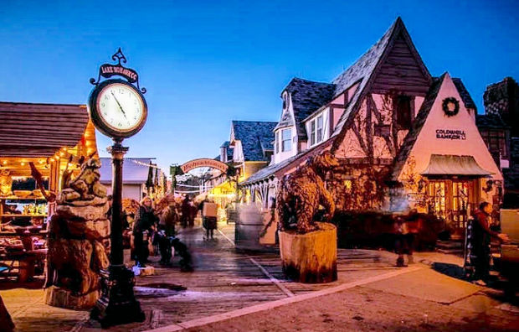
Departs from South Plainfield High School at 7:15 AM and returns at approximately 6:15 PM. As you enter from Lane Ave, park on the left by the fence between the two schools.

Departs from Chatham Middle School, 480 Main St, at 8:30 AM and returns at approximately 5:30 PM.

Departs from Frelinghuysen Middle School at 9:00 AM and returns at approximately 5:00 PM

Cars may be parked at any location for the duration of the tour at your own risk.

German Weihnachtmarkt

No reservations accepted without a payment of $160 per person. Make checks payable to "Group Tours & Travel” and mail to the above address. Group Tours is not responsible for any delays, cancellations, or circumstances beyond its control and reserves the right to change this itinerary. All trip components are subject to change in accordance with Government, State and Local guidelines and/or mandates. This tour will run rain or shine. A full refund will be granted if cancelled prior to November 1, 2021. No refund will be granted on a cancellation after November 1, 2021. For a more complete list of tours and pictures, visit our website www.grouptoursandtravel.com. Fkdfjsdlksdjdfgfdgfdgfdgfgfdgfgfd
--------------------------------------------------------------------------------------------------------------------------
A Winter Day in Germany ~ Sunday, December 5, 2021

Please reserve _____ seat(s). The enclosed check is for $_____________ #3232

Name(s): Phone:
Address: Zip Code

I will be departing from South Plainfield _______ from Chatham ________ from Morristown _________

For email confirmation of registration:_________________________________________________________________________________________________________

