Group Tours & Travel 1710 E. Lancaster Ave. #319 Paoli, PA 19301

Dream. Wander. Discover. 973-513-9001

grouptoursandtravel.com

Amore Italia
Historic Smithville Italian Festival & Lucy the Elephant
One Day Tour ~ Saturday, September 24, 2022

Have you been craving the tastes, sounds and scents of Italy? Then the Historic Smithville Italian Festival is the perfect place for you! It will be amore for everything Italian today as we celebrate the rich Italian culture and heritage of the region. Follow the aroma of sausage and peppers, meatballs, and pizza in the air as you’re serenaded by the sounds of Italian crooners and festive accordionists. There will of course be local wine tasting vendors and Italian beer on tap to pair with some delicious, homemade Italian desserts. Browse the vendor market filled with hand crafted items and imported Italian specialties. If you’re up for some action, join in the Italian Folk dancing and free Bocce ball! After our taste of Italy, we’ll visit the iconic and newly renovated Lucy the Elephant who towers six stories over the beach in Margate. Built in 1881 as a gimmick to attract potential land buyers to the region, Lucy has persevered through the decades and became a National Historic Landmark with a newly completed restoration. Our guided tour will take us inside “The World’s Largest Elephant” where we’ll learn about her storied past, look through her eyes, and marvel at her fabulous facelift! 2022 Group Tours & Travel

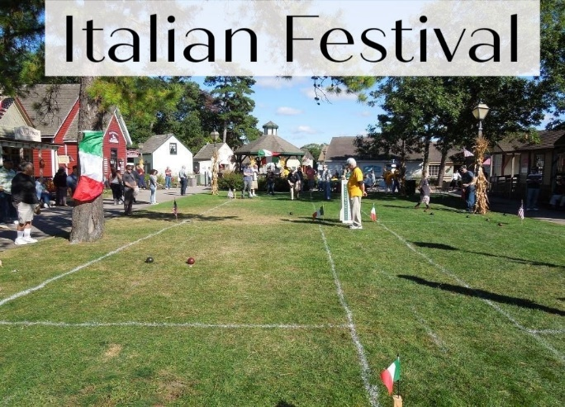 Bocce Ball Tournament No reservations accepted without a payment of $145 per person. Make checks payable to "Group Tours & Travel” and mail to the above address. A full refund will be granted if cancelled on or before August 27, 2022. No refund will be granted on a cancellation after August 27, 2022. Group Tours is not responsible for any delays, cancellations, injuries or circumstances beyond its control and reserves the right to change this itinerary. All trip components are subject to change in accordance with Government, State and Local guidelines and/or mandates. Rain date is: Sunday, September 25. Visit grouptoursandtravel.com for additional tours and photos.
Departs Ridgewood’s Graydon Pool parking lot (corner of Linwood Avenue & Northern Parkway) at 7:30 AM and returns at approximately 7:00 PM.

Departs Morris Plains Community Center, 51 Jim Fear Drive at 8:15 AM and returns at approximately 6:15 PM.

Departs South Plainfield High School at the end of Lane Ave.at 9:00 AM and returns at approximately 5:30 PM.

Cars may be parked at all locations at your own risk.

---------------------------------------------------------------------------------------------------------------------------------------
Amore Italia: Italian Festival ~ 1 Day Tour ~ Saturday, September 24, 2022

Please reserve ________ seat(s). The enclosed check is for $_____________ #3267

Name(s): Phone:

Address: Zip Code

I will be departing from Morris Plains _____ from South Plainfield _____ from Ridgewood _________

Add Email for registration confirmation/final payment notice:____________________________________________________________________________

